## UML Diagrams

### UML Use Case Diagram

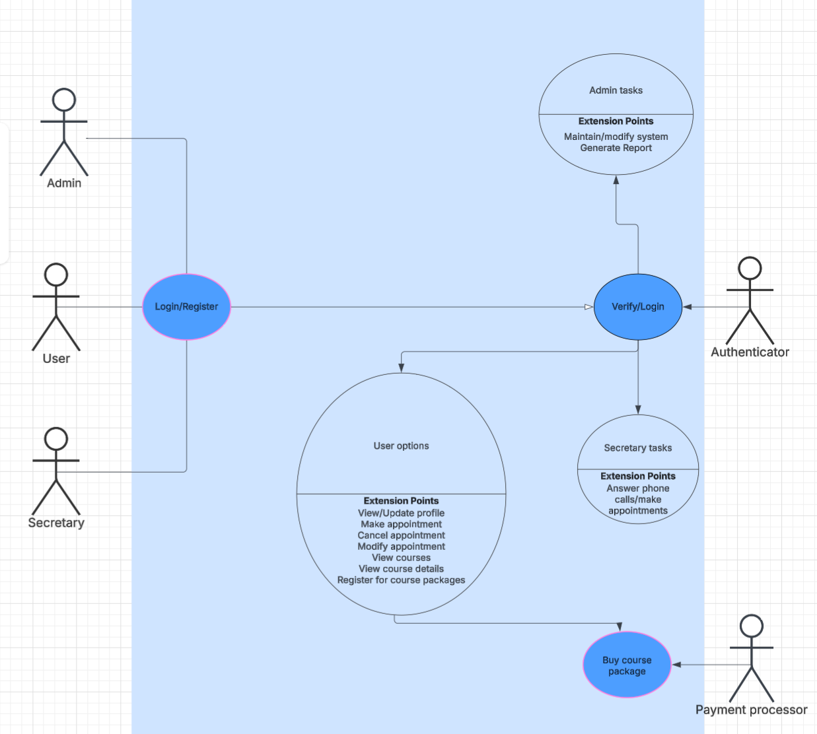

### UML Activity Diagrams

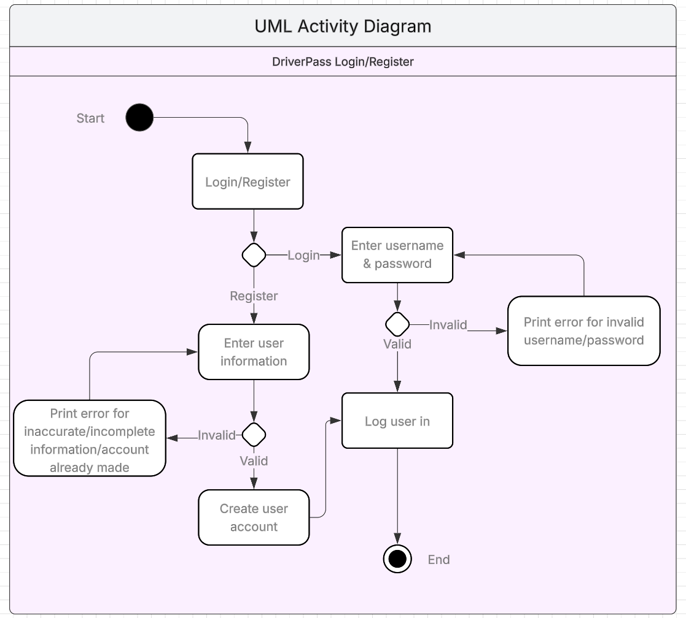

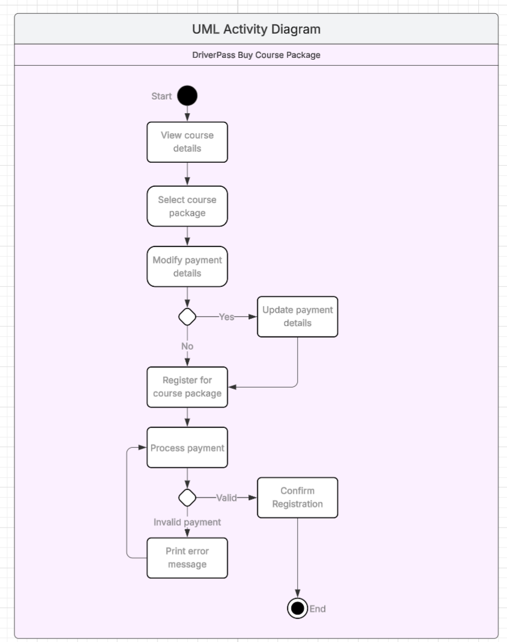

### UML Sequence Diagram

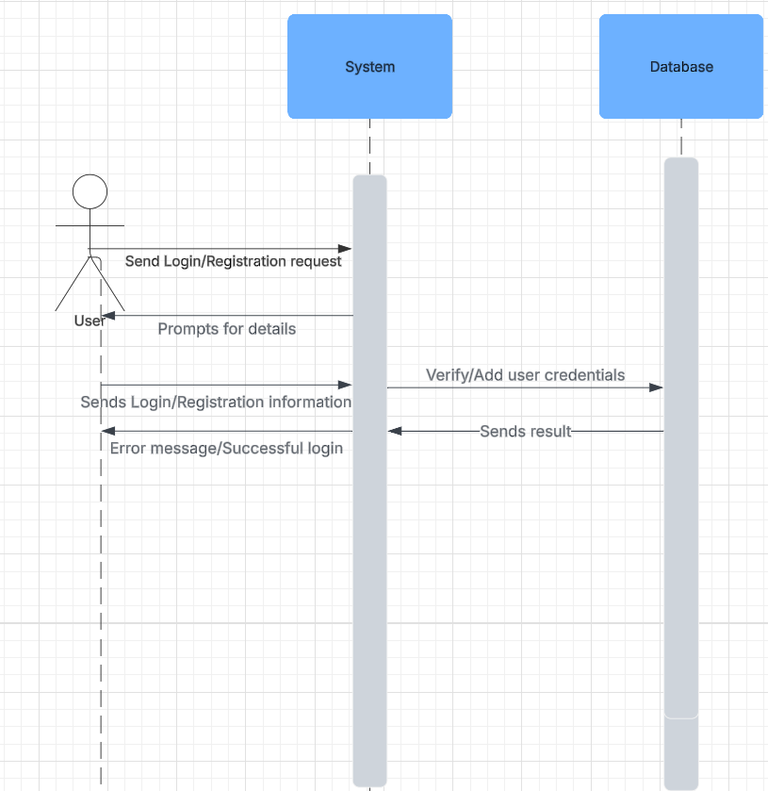

### UML Class Diagram

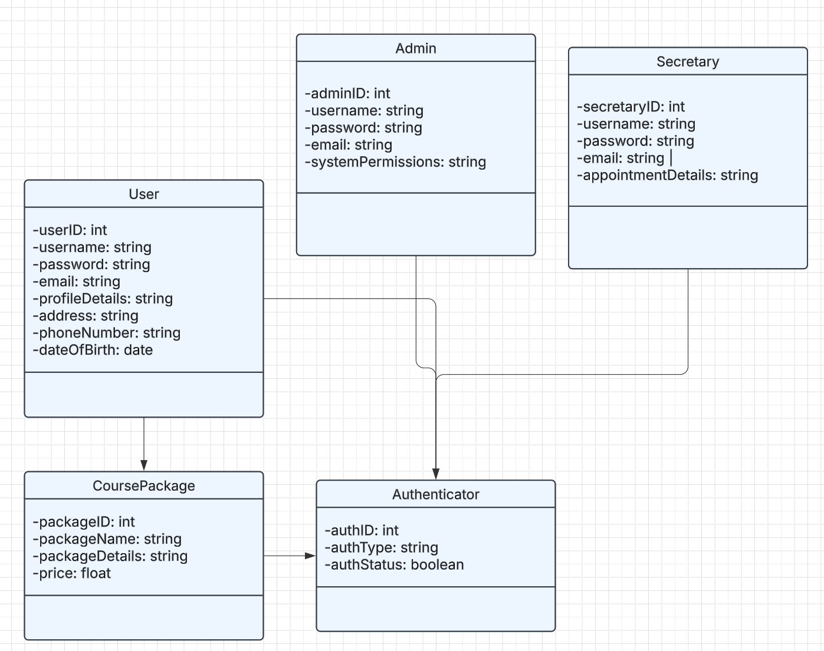

profileDetails includes first name, last name, phone number, state, credit card number, expiration date, and security code. It would be hard to fit all of that into one class on screen otherwise.

## Technical Requirements

The DriverPass system requires good hardware and software to ensure seamless operation and user experience. High-performance servers with multi-core processors, ample RAM, and SSD storage are essential for hosting the web-based application and handling user requests. Client devices, including modern computers, tablets, and smartphones, must support various operating systems such as Windows, macOS, Linux, iOS, and Android. The system will utilize web-based frameworks like HTML, CSS, JavaScript, for front-end development, while backend processing will be handled by Node.js, Python, or Java. A SQL database will store user information, course details, appointments, and authentication data, with cloud services like AWS, Azure, or Google Cloud Platform providing infrastructure for hosting and data storage. Security measures, including SSL/TLS encryption and monitoring tools will protect data exchange and user information. Development tools such as IntelliJ, IDEA, and GitHub will make collaboration easier and introduce version control, while CI/CD platforms like GitHub Actions will automate testing and deployment. Reliable internet connectivity with sufficient bandwidth is crucial for handling up to 10,000 concurrent users, and backup solutions will ensure data integrity and availability. This comprehensive setup will enable DriverPass to offer online courses, practice tests, and on-the-road training effectively, meeting the client's needs and ensuring a high rate of success for new drivers.